Year 12 MAS 3C/3D February 2010

TEST 1 (Complex Numbers & Vectors)
Worth 5% of the Year Mark 50 minutes permitted.

Name : Score :
(out of 60)

1. [10 marks]

Given complex numbers z and w where z = 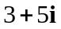 and w = 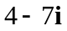

(a) Determine, exactly

(i) z – w

[2]
(ii) Re (z) – Im (w)

[1]

(iii) 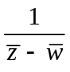

[3]

(b) Find the value of a such that az + 3w = 6 – 31i

[4]
2. [8 marks]

Consider the complex numbers u = 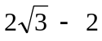i and v = i – 1

(a) Write u and v in exact polar form.

[3]
(b) Simplify 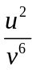 , leaving your answer exactly in polar form.

[3]

(c) Find exactly u + 2v

[2]
3. [9 marks]
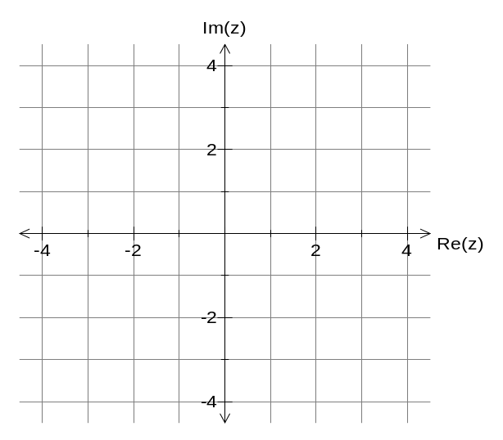(a) Sketch the graphs in the Argand Plane to indicate the set of numbers z that satisfy :

(i) 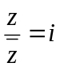

[3]

(ii) 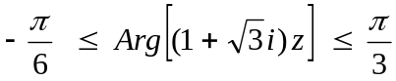

[3]

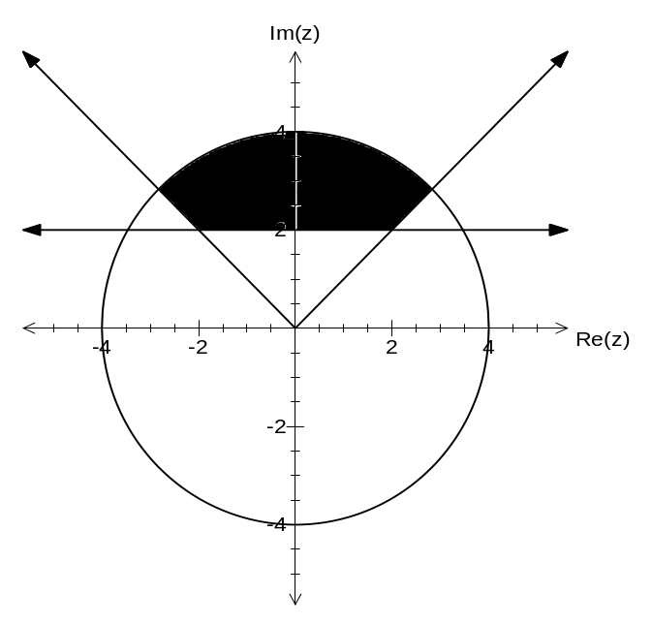(b) Describe the shaded region in the Argand plane below. [3]
4. [5 marks]

For the region in the Argand plane defined by the inequality 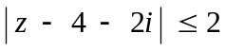,

determine the maximum and minimum value for the argument of z.

5. [5 marks]

(a) State the geometrical relationship between the complex numbers w and z if it is known that w = iz

[2]

(b) The three points A, B and C in the Argand plane correspond to complex numbers z₁ , z₂, and z₃ respectively. The triangle ABC is isosceles and has a right angle at A.

Write down algebraically the relationship between z₃ – z₁ and z₂ – z₁.
Explain how you arrived at your answer.

[3]

6. [23 marks]

Consider the following vectors in space :

a = 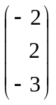, b = 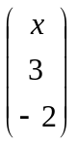, c = 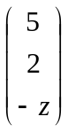, and d = 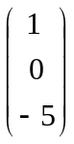
Determine :

(a) vector e such that e is parallel to d and double its length.

[1]
(b) the acute angle between vectors a and d (to nearest degree).

[3]
(c) the relationship between x and z if c is perpendicular to b.

[2]
(d) the value of x such that a is parallel to b.

[3]
(e) vector f such that f is in the direction of a with a magnitude of 17 units.

[3]
(f) a vector which is perpendicular to both a and d.

[4]

Suppose that vectors a and d represent position vectors of points A and D respectively.

(f) Determine the position vector p for the point P which divides  internally in the ratio 3:1.

[4]

(g) Determine the vector equation for the line in space that connects points A and D.

[3]
End of Test

